МЕДИАТЕКА ОТДЕЛА ЛИТЕРАТУРЫ НА ИНОСТРАННЫХ ЯЗЫКАХ

КИНОКЛУБ «РАКУРС»
предлагает циклы демонстраций документальных фильмов на иностранных языках
«История XX века»
на английском языке
«Our Century»
(реж. П. Филипп, Gaumont, Oracle, 2004 г., 9 серий по 52 мин.,12+).

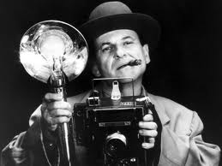
15 апреля 16.00 –
«1900-1914. A New World»
18 апреля 16.00 –
«1914-1918. Beyond the Front»
22 апреля 16.00 –
«1918-1928. The Years of Jazz»
29 апреля 16.00 –
«1928-1939. Great Illusions»

”Our Century” is an outstanding series of 9 programmes, comprising exceptional film archives made throughout the last century. It covers the great international events that marked both our history and everyday life and also addresses the major issues of the time.
«История американского кино»
на английском языке
«A personal journey with Martin Scorsese through American movies»
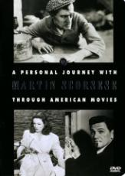
(США, 1995 г.)
3 апреля в 13.00 – часть 1 (72 мин., 12+).
10 апреля в 13.00 – часть 2 (80 мин., 12+).
17 апреля в 13.00 – часть 3 (73 мин., 12+).

Despite its nearly four-hour running time, this is a uniquely personal look at movies from one of the late 20th century's great directors and film historians. The film consists of head & shoulder shots of Scorsese speaking into the camera for a minute or two, followed by 10-15 minutes of film clips with Scorsese voice-over. Scorsese approaches the films in terms of how they affected him as a director foremost and as a storyteller/film fan second. Segments include "The Director as Smuggler," "The Director as Iconoclast", and so on. The Journey begins with silent masters like D.W. Griffith and ends in 1969 - when Scorsese began to make films; as he says in closing, "I wouldn't feel right commenting on myself or my contemporaries.

Вход свободный. Наб. реки Фонтанки, д. 46, медиатека ИНО,
т. 571-00-04.

